[](https://drive.google.com/file/d/1oAGd1es6RyVEJe2CcSRm09-6KdrVwNKc/view?usp=sharing)[](https://drive.google.com/file/d/1WYbjrjpvdwFEEgZf3lfClCuwrRpmIEqo/view?usp=sharing)[](https://drive.google.com/file/d/1ml6bjW2dORl18REvCUx0NxvxF9Ad5KDT/view?usp=sharing)[](https://drive.google.com/file/d/1MqOCUaFsGdmUcGADDfVLPtcK3FOwXVuW/view?usp=sharing)[](https://drive.google.com/file/d/1YLTdChMTszFlWm3wHmMQVSpkQCle04Vj/view?usp=sharing)[](https://github.com/dhanikitkat)[](https://www.linkedin.com/in/mramdhani21/)[](https://dhanikitkat.github.io/porto.github.io/portofolio/)[](mailto:mramdhani2112@gmail.com)[](https://api.whatsapp.com/send/?phone=6282210403837&text=Saya+tertarik+dengan+profil+Anda.)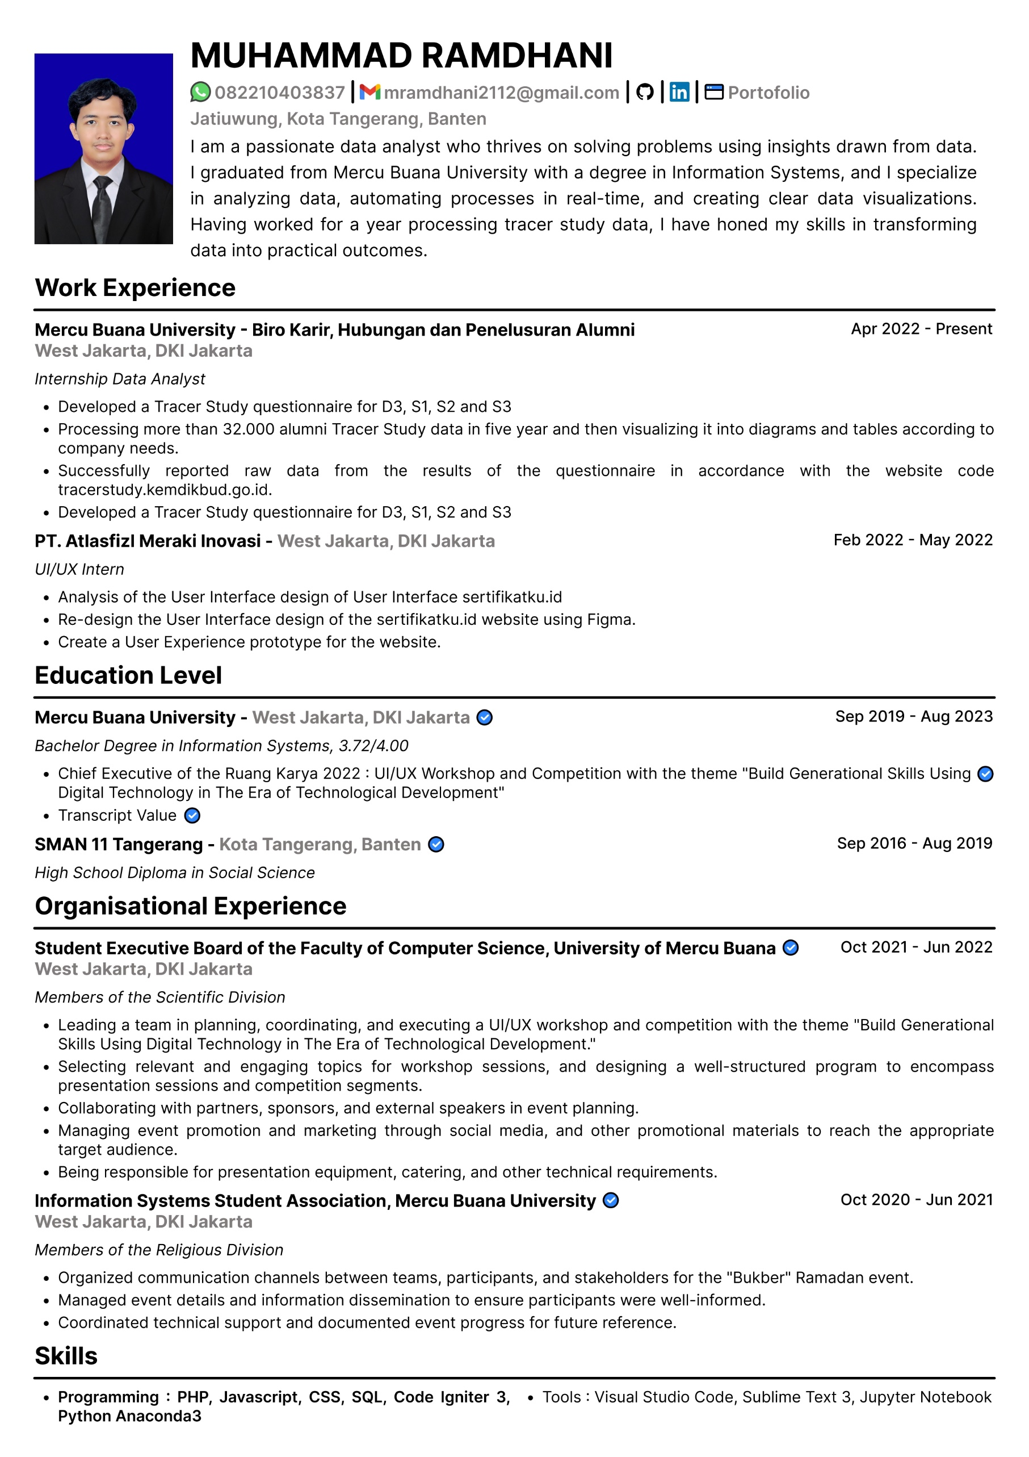dawdw

[](https://drive.google.com/file/d/1bX3WAtb1DWxK3aohqJQ3DaMRXNeDZnKL/view?usp=sharing)[](https://drive.google.com/file/d/1nT9kxrPSoV0t0RKELN4Is8nybb7CBJq3/view?usp=sharing)[](https://drive.google.com/file/d/1WiWtjARTW8tsttvwzPPHZgaHA-WeCtOL/view?usp=sharing)[](https://drive.google.com/file/d/10s-6ah-zGpKrKh5N2nGmuB7Cs7c4X_QH/view?usp=sharing)[](https://drive.google.com/file/d/1u3sfcVCbgsdOQ5jqPTQQ1z4OruFkS0kp/view?usp=sharing)[](https://drive.google.com/file/d/1BO0uyu5tubRmQwujcCiQ2iUxdv4cAODg/view?usp=sharing)[](https://drive.google.com/file/d/12ER9nB1cS2EDXTQYjw4Y0Ire_3edqKzm/view?usp=sharing)